Create New Account part 1/2

Login Screen

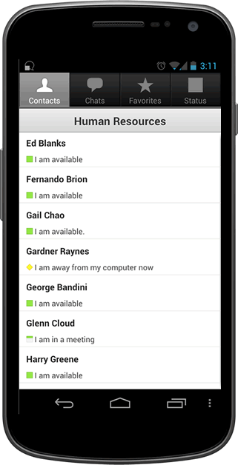

**Carpool**

User Name

Password

Confirm Password

First Name

Last Name

**Create New Account**

Street Address

City

State

Zip

Do you own a car?

Yes

No

Phone Number

Email



Create New Account

forgot password

**Carpool**

User Name

Password

forgot user name

Main Menu

Create new Account part 2/2



**Carpool**

Location: 145 Marcus way

Available: M W F

Depart to work: 7:15 am

Depart to home: 5:30 pm

Available Seats: 2

Contact Me

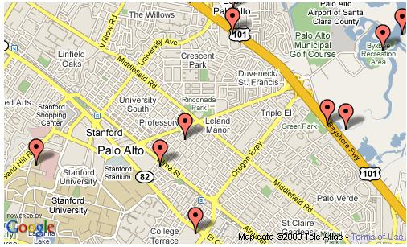

John Doe



**Carpool**

Max Passengers

Vehicle Type

**Create New Account**

Create Account

Cancel

Do you own a vehicle?

Yes

No

Truck

Van

SUV

Car

Car Description

Other

Example, my car is a two door, white Toyota Camry with a sun roof.

Selection menu if your own group is selected

Selection menu if contact me is selected



**Carpool**

Location: 145 Marcus way

Available: M W F

Depart to work: 7:15 am

Depart to home: 5:30 pm

Available Seats: 2

Options



John Doe (You)



Edit

Delete

Send message to group

View group members



**Carpool**

Location: 145 Marcus way

Available: M W F

Depart to work: 7:15 am

Depart to home: 5:30 pm

Available Seats: 2

Contact Me



John Doe



Call

Message

Sent Invite Request

View group members



**Carpool**



Days for Pickup

9:00 AM

Pickup Address

M T W Th F Sat Sun

Departure

to Home

5:00 PM

Pickup time:

Create Pickup Location

Cancel

3

Available Seats:

3

Drivers Fee: $

Calculate Fee

Menu if search is selected

Menu if create meeting place is selected



**Carpool**



Mile Radius (25 mile Limit)

Pick up Address

Search

Cancel

Menu if personal settings is selected

Menu if view group members are selected



**Carpool**

Location: 236 Marcus way

Abingdon Va 24210

276-777-7777

John.Doe@yahoo.com

Available: M W F

Contact Me

Steve Smith

145 Marcus way

Abingdon Va 24210

276-999-9999

John.Doe@yahoo.com

Available: M W F

Contact Me

John Doe (Driver)

Location: 156 Marcus way

Abingdon Va 24210

276-888-8888

Jane.Doe@yahoo.com

Available: M W F

Contact Me

Jane Doe



**Carpool**

John

User Name

Password

Doe

John.Doe

******

******

Confirm Password

First Name

Last Name

**Account Management**

Street Address

145 Marcus Way

City

Abingdon

State

Zip

VA

24210

Do you own a car?

Yes

No

Phone Number

276-999-9999

Email

John.Doe@yahoo.com



**Carpool**

Add Total to Fee

Exit Calc

Calculate Fee

Vehicle’s mpg

Distance of trip (miles)

Number of Passenger

(do not include driver)

Cost for gas (per gal) $

Total

$0.00

Driver’s Fee Calculator

Driver’s Fee Calculator

Calculation for Driver’s Fee:

Total= 

Google maps image: <http://www.codeproject.com/Articles/36151/Show-Your-Data-on-Google-Map-using-C-and-JavaScrip>

Green icon: <http://www.graphicsfuel.com/wp-content/uploads/2011/03/gps-map-icons.png>

Android phone <http://www-10.lotus.com/ldd/insidelotusblog.nsf/dx/new-sametime-chat-apps-for-android>

Log in

Username

Password

Account creating

First Name

Last Name

User Name

Password

Address

Street, city, state, zip

Phone number

Car?

make

model

year

number of occupants (vehicleSize)

Driver?

Days will drive?

* pickup address
  + depart time
* meet time
* work leave time
* work arrival time

Group list

* Days will drive?
* pickup address
* depart time
* meet tme
* work leave time
* work arrival time